HCI & COMPUTER GRAPHICS
ASSIGNMENT NO 1

NAME: AHTESHAM ALAM
ROLL NO: 2K24/CSE/22
SUBJECT: HCI & COMPUTER GRAPHICS
CLASS: 3RD YEAR CS (PE)
SUBMITTED TO: SIR RAJESH KUMAR
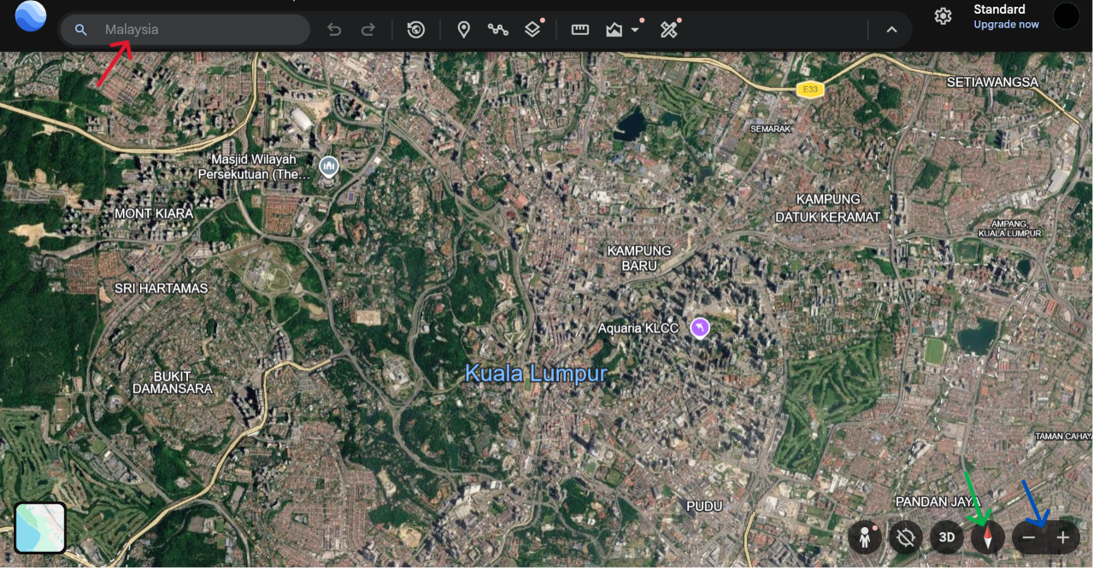
Search Bar: The Search Bar in Google Earth is used to search for and quickly locate specific places, addresses, landmarks, or locations on the Earth.
Navigation Bar:The Navigation Control is used to move, rotate, tilt, zoom in, and zoom out of the map to explore different locations and views.
Zoom Controls : The Zoom Control in Google Earth is used to zoom in and zoom out to view a location more closely or from a wider area.

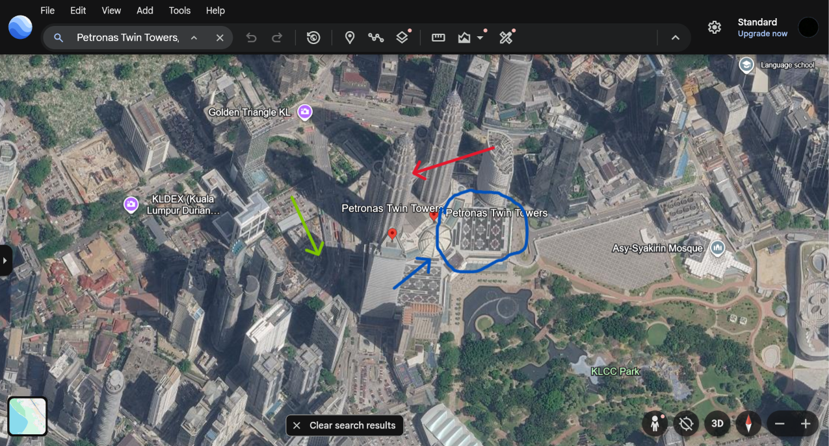
3D Geometry: The 3D Geometry is used to display buildings and structures with realistic height, shape, and depth for a three-dimensional view.
Shadows (Light Source): The Shadow (Light Source) is used to show the direction and position of sunlight by displaying shadows cast by buildings and other objects.
Texture Mapping : The Texture Mapping in Google Earth is used to apply realistic images and surface details to 3D buildings, roads, and other objects.

Question No 1
How does the Computer Graphics quality (e.g., realistic lighting or 3D view) help or hinder the userʼs ability to interact with the software?
Answer:
High-quality computer graphics make software more interactive and easier to use. Features such as realistic lighting, shadows, textures, and 3D views help users recognize buildings, streets, and landmarks more easily. They also make it easier to explore places from different angles and understand the surroundings.

Question No 2
What is one simple HCI change you would make to improve the user interface?
Answer:
One simple HCI change I would make is to use clear and easy to understand icons with short labels or tooltips. This would help users understand each feature more easily and make the interface more user-friendly, especially for new users.

